

**ENGLISH PROFICIENCY TEST (EPT)**

**PRACTICE SET 2**

**SECTION 2**

**STRUCTURE AND WRITTEN EXPRESSION**

**Time: 25 minutes**

**Now set your clock for 25 minutes.**

This section is designed to measure your ability to recognize language that is appropriate for standard written English. There are two types of questions in this section, with special directions for each type.

**Structure**

Directions: These questions are incomplete sentences. Beneath each sentence you will see four words or phrases, marked (A), (B), (C), and (D). Choose the one word or phrase that best completes the sentence. Then, on your answer sheet, find the number of the question and fill in the space that

corresponds to the letter of the answer you have chosen.

Look at the following examples.

**Example I**

The president __ the election by a landslide.

(A) won

(B) he won

(C) yesterday

(D) fortunately

The sentence should read, **"The president won the election by a landslide."** Therefore, you should choose answer **(A).**

**Example II**

When __ the conference?

(A) the doctor attended

(B) did the doctor attend

(C) the doctor will attend

(D) the doctor's attendance

The sentence should read, **"When did the doctor attend the conference?"** Therefore, you should choose answer **(B).**

1. **– 2 – 2 – 2 – 2 – 2 – 2 – 2 – 2**
2. Indiana's Lost River __ underground for a distance of 22 miles. usually act
   1. travels
   2. traveling
   3. to travel
   4. it travels
3. The 1980 explosion of __ the first volcanic emption in the continental United States in over 60 years. the Sun is
   1. Mount St. Helens
   2. Was Mount St. Helens
   3. It was Mount St. Helens
   4. Mount St. Helens was
4. Static e1eco'icity __ one cloud to another or between clouds and the ground creates lightning.
   1. flows from
   2. the flow from
   3. flowing from
   4. is flowing from
5. The Model T car, introduced in 1908, __ $850
   1. the price was
   2. a price of
   3. to be priced at
   4. was priced at
6. __ reacts with a chlorine atom, an electron is transferred from the outer shell of the sodium atom to the outer shell of the chlorine atom.
   1. A sodium atom
   2. When a sodium atom
   3. For a sodium atom
   4. It is a sodium atom
7. In 1858, the site __ was to become the city of Denver was settled as a way station for outfitting gold prospectors
   1. it
   2. of it
   3. what
   4. of what
8. The light from an electrical lamp includes many different wavelengths, __ in a laser is concentrated on only one wavelength
   1. all the energy
   2. it is all the energy
   3. while all the energy
   4. while all the energy is
9. In the Antarctic Ocean __ plankton and crustacean forms of life
   1. an abundance of
   2. is an abundance of
   3. it is abundant
   4. an abundance is
10. Flintlock muskets __ sharp bayonets were standard weapons during the American Revolution.
    1. tip with
    2. tipped with
    3. the tips of
    4. were tipped with
11. Benjamin Franklin believed that the turkey rather than the eagle __ of the United States
    1. should become the symbol
    2. the symbol becomes
    3. should symbolize becoming
    4. becoming the symbol
12. __ to occur in the Earth's crust. Push-pull and shake waves would be generated simultaneously.
    1. Were a break
    2. If a break
    3. A break was
    4. If broken
13. Fossil fuels like coal, oil, and gas produce carbon dioxide when __
    1. are burned
    2. they burned
    3. burned
    4. are they burned
14. Not until Nellie Tayloe Ross was elected governor of Wyoming in 1924 __ as governor of a U.S. state.
    1. a woman served
    2. a woman serving
    3. to serve a woman
    4. did a woman serve are they disturbed
15. The temperatures __ take place vary widely for different materials.
    1. which melting and freezing
    2. at which melting and freezing
    3. which they melt and freeze
    4. at which they melt and freeze
16. In general, the cells of large animals and plants are only slightly larger than __ plants and animals.
    1. smaller
    2. are smaller
    3. those smaller
    4. are those of smaller

**Written Expression**

Directions: In these questions, each sentence has four underlined words or phrases. The four underlined parts of the sentence are marked (A), (B), (C), and (D). Identify the one underlined word or phrase that must be changed in order for the sentence to be correct. Then, on your answer sheet. Find the number of the question and fill in the space that corresponds to the letter of the answer you have chosen.

Look at the following examples.

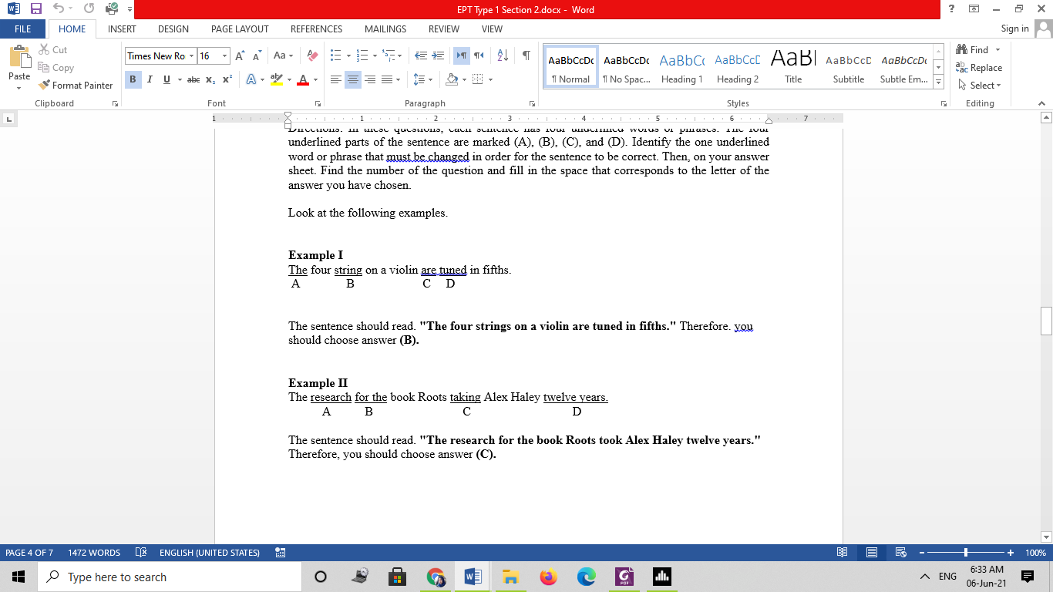

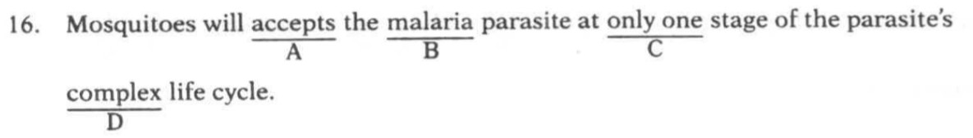

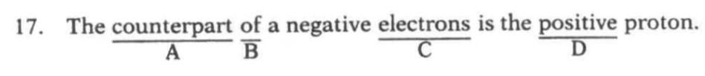

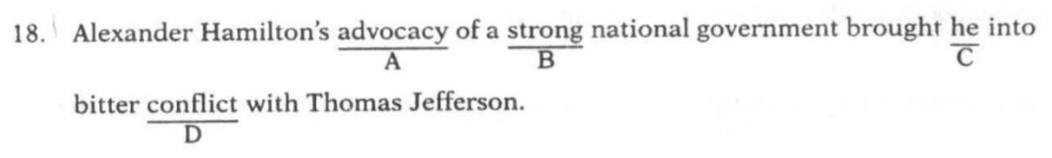

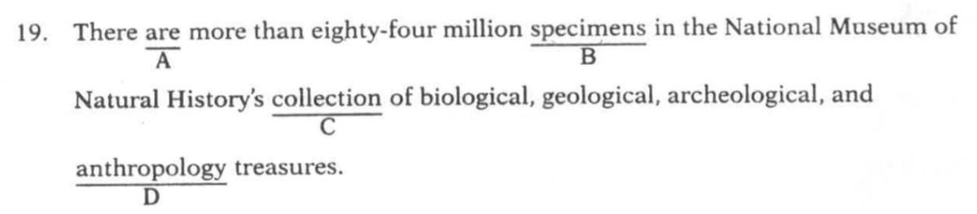

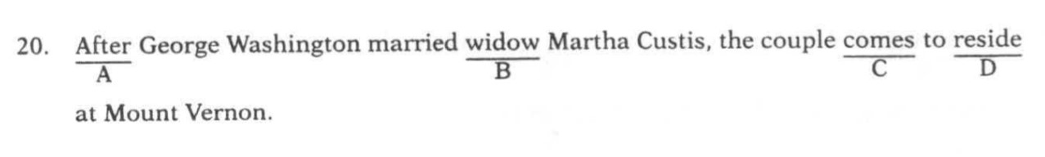

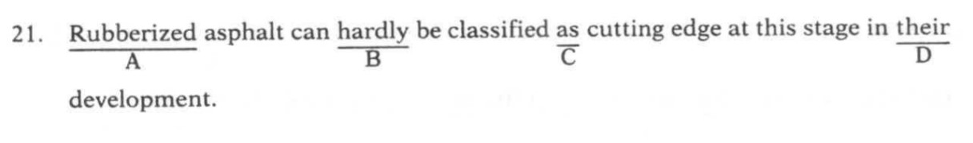

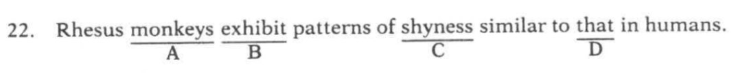

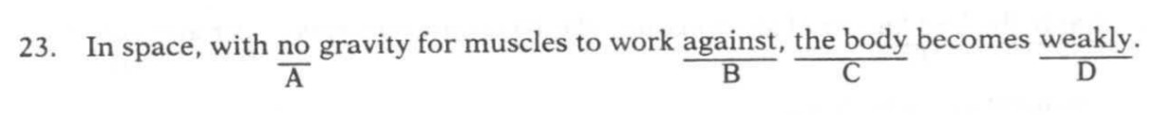

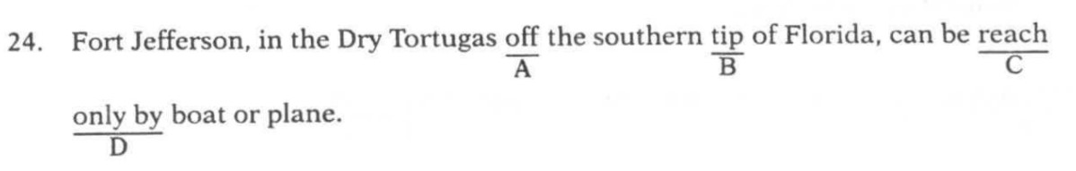

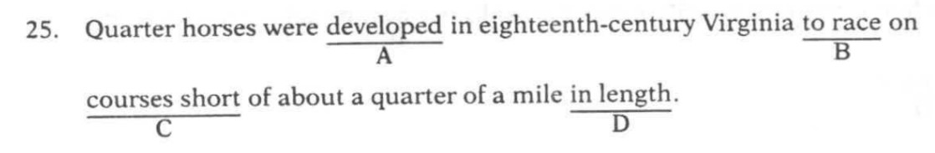

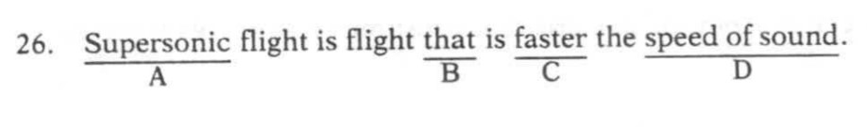

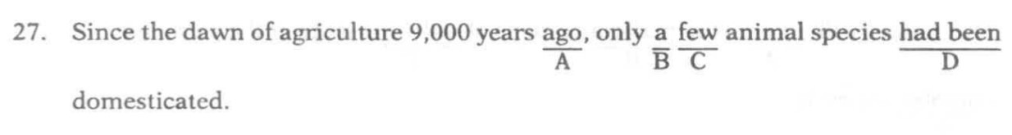

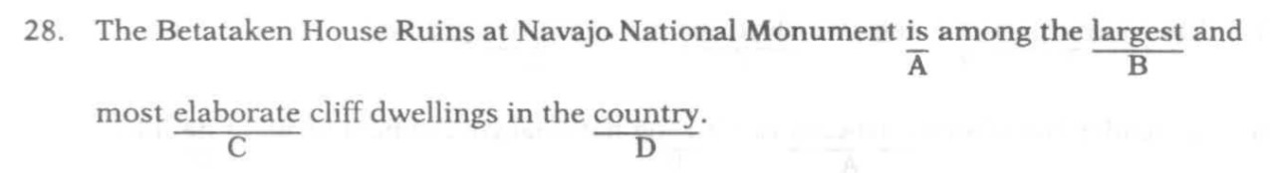

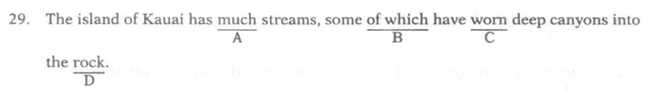

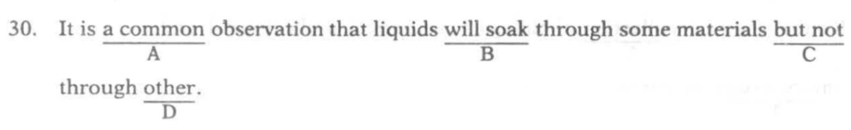

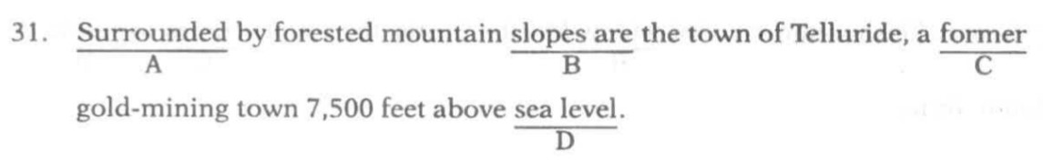

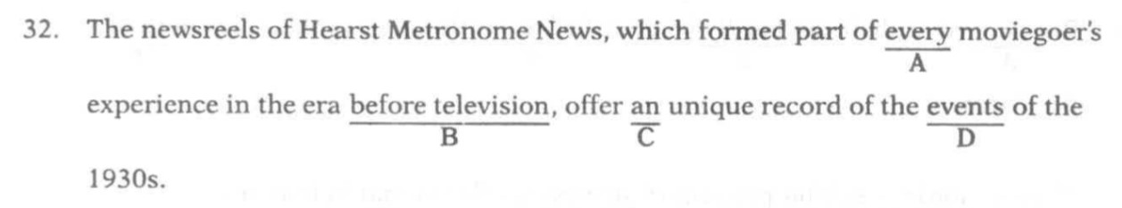

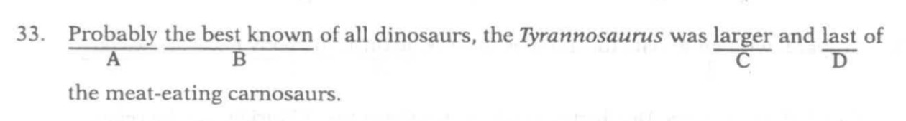

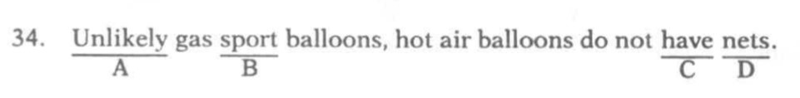

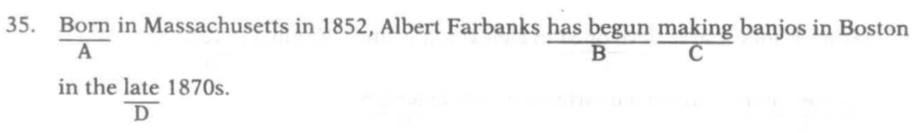

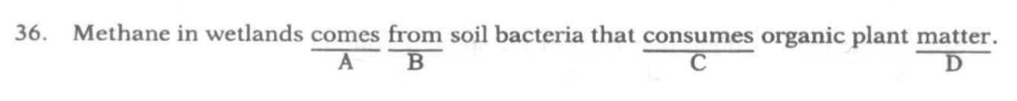

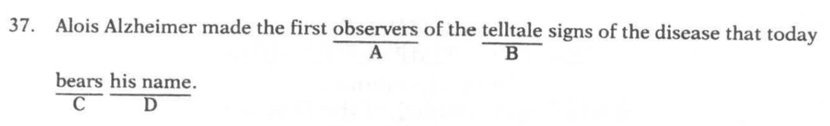

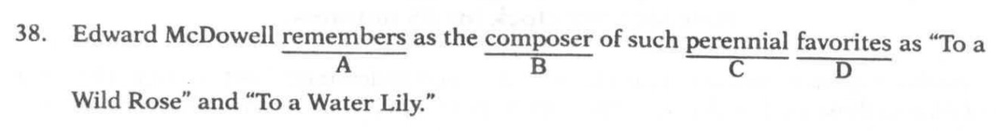

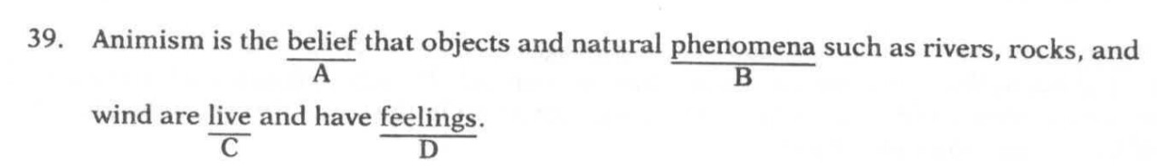

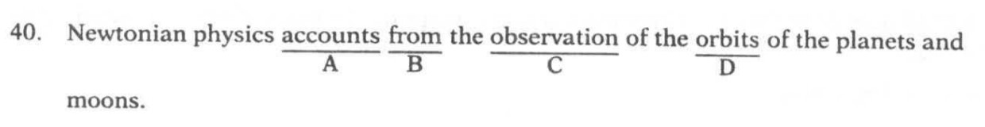

**This is the end of Section 2.**

**If you finish before 25 minutes has ended,**

**Check your work on Section 2 only.**

**At the end of 25 minutes, go on to Section 3.**

**Use exactly 55 minutes to work on Section 3**.